Google Meet – St. Peter’s CofE Primary School Parent Guide

In order to use Google Meet, your child will need to be logged into their school Google account.

1. We recommend downloading Google Chrome onto your laptop or PC, if you do not already use this.

[Download Google Chrome here.](https://www.google.co.uk/chrome/?brand=CHBD&gclid=EAIaIQobChMI85DUn8az6AIVGODtCh3X7AD2EAAYASABEgIQ1PD_BwE&gclsrc=aw.ds) Google Chrome is a web browser. The Microsoft equivalent is Internet Explorer.

1. Access the [Google log-in page](https://accounts.google.com/signin/v2/identifier?flowName=GlifWebSignIn&flowEntry=ServiceLogin) here or type ‘Google login’ into your Google Chrome browser. ***If you already use a Google/Gmail account at home, you will need to log out of it.***

Note: if you are using a [Chromebook](https://en.wikipedia.org/wiki/Chromebook)**,** we recommend using the ‘add a person’ option when at the log-in screen.

1. If using a phone, iPad or tablet, both the Google Calendar and Google Meet apps need to be downloaded. Log into each app with the pupil’s school login (see below).
2. The Google login screen looks like this:

In the email line, enter your child’s first name and surname initial, followed by ***@spmillend.herts.sch.uk***

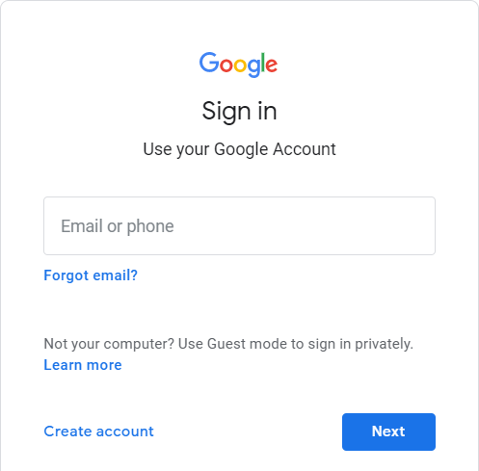

For example:

# [JohnS@spmillend.herts.sch.uk](mailto:JohnS@spmillend.herts.sch.uk) Then click ‘Next’.

1. Enter your child’s password as follows:

**Stpeters1**

This is the same password for all. Once logged in, you may change this.

# Joining a Google Meet session on a PC or laptop:

At the meeting time, pupils should log into their Google account and go to the Google Meet app. The scheduled meeting will be visible to select and join. Alternatively, the meeting can be accessed from Google Calendar by clicking on the meeting and selecting ‘Join with Google Meet’.

# At the end of the session:

Leave the session when instructed to do so by clicking on the red telephone button at the bottom of the screen.

# Online safety in Google Meet sessions

Please take note of the following points regarding online safety, as detailed in the school’s Remote Learning Policy:

All staff and pupils using video communication must:

* Wear suitable clothing – this includes others in their household.
* Be situated in a suitable ‘public’ living area within the home with an appropriate background – ‘private’ living areas within the home, such as bedrooms, are not permitted during video communication.
* Use appropriate language – this includes others in their household.
* Maintain the standard of behaviour expected in school.
* Use the necessary equipment and computer programs as intended.
* Not record, store, or distribute video material without permission.
* Ensure they have a stable connection to avoid disruption.
* Always remain aware that they are visible.

All staff and pupils using audio communication must:

* Use appropriate language – this includes others in their household.
* Maintain the standard of behaviour expected in school.
* Use the necessary equipment and computer programs as intended.
* Not record, store, or distribute audio material without permission.
* Ensure they have a stable connection to avoid disruption to lessons.
* Always remain aware that they can be heard.