

**St. Peter’s Church of England (VA) Primary School**

**Home Learning Arrangements**

Below are the details of the remote curriculum which all children are expected to undertake during the current period of school closure. At St. Peter’s, we will be using a hybrid of live lessons and other resources for example Oak Academy and White Rose.

Live sessions will be delivered through zoom/Google Meet. Google Meet or Zoom meeting details will be placed on Google Classroom or emailed out. Daily pre-recorded/narrated maths, spelling, writing key skills and spelling sessions will be released during the day in addition to follow up learning and other curriculum learning/project based topics. Science and other curriculum learning will be shared via Google Classroom.

If using a tablet or phone, you will need to download the following apps:

* Google Classroom
* Google Docs
* Google Slides
* Google Meet

These apps will allow you to access our home learning offer. If you are using a laptop or desktop computer, you will be able to access our home learning through your usual internet browser.

The sessions the teachers are creating are different to those the children will usually experience in school. Learning is a collaborative process which requires teachers to provide immediate personalised feedback and a constant change of pace and direction. This will not be the same remotely. The learning will be more instructional.

Each class in KS1 and KS2 will have a class review session with Mr Conley on Friday afternoons and a whole school assembly every day. Below are the timings for the classes.

1.00pm – Yr1

1.30pm – Yr2

2.00pm – Yr3

2.30pm – Yr4

3.00pm – Yr5

3.30pm – Yr6

For the Foundation Stage, Mr Conley will be having a check in on a Thursday.

1.00- Nursery

1.30- Reception

We recognise that many parents will need to balance their own work demands, sharing of devices, siblings/different learning and much more. The timetable below has been developed following feedback from parents/carers after the previous school closures. Class teachers will take the register at the start of each live session.

All pupils must be dressed for sessions (no pyjamas) and in an open room (not bedrooms) with an adult nearby. Any pupil who is not dressed or in a bedroom or other inappropriate space will be ejected from live sessions. Any disruption to live sessions or inappropriate use of Google Classroom chat bars will lead to a pupil being ejected from the learning space. We will be keeping a record of those that attend sessions so that if children regularly do not attend, a member of SLT will be in contact.

If you are finding aspects of the timetable and learning difficult please get in contact with school.

**NB-** For Art and Forest school sessions, the children between Years 1 to 6 will be issued with an hours’ worth of work each week. This will need to be completed at a time that is convenient for you. For French, there will be a session for all children from EYFS to Year 6. This will also need to be completed at a time convenient

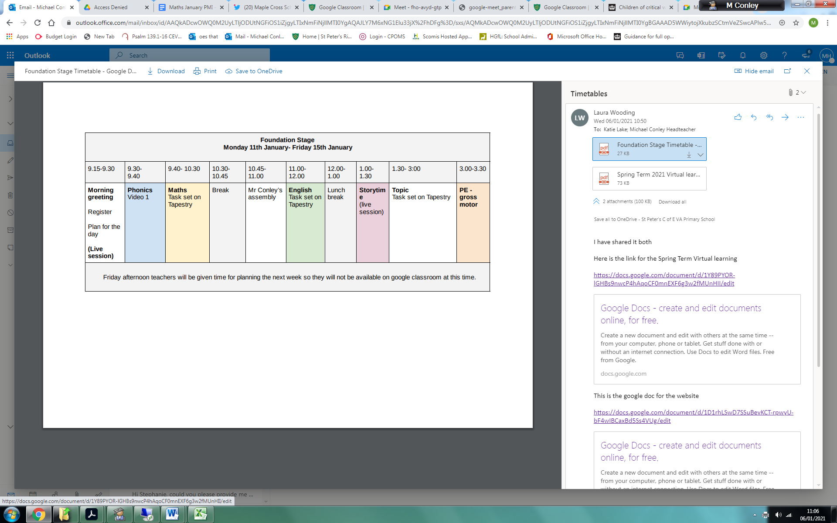

|  |  |  |  |  |  |  |  |  |  |  |
| --- | --- | --- | --- | --- | --- | --- | --- | --- | --- | --- |
| **Key Stage 1** | | | | | | | | | | |
| 8.45-9.00 | 9.00-  9.30 | 9.30- 10.30 | 10.30- 10.45 | 10.45- 11.00 | 11.00- 12.00 | 12.00- 1.00 | 1.00- 2.30 | 2.30- 2.45 | 2.45- 3.00 | 3.00-3.30 |
| Morning greeting  Register  Plan for the day  **(Live session)** | **Phonics**  (Video 1 with follow up work on google classroom) | **Maths**  (Video 2 with follow up work on google classroom) | Break | Mr Conley’s assembly | **English**  (Video 3 with follow up work on google classroom) | Lunch break | **Afternoon lesson**  Google classroom | Break | Storytime  Check in with class teacher  Google Chat  **(Live session)** | **PE with Joe** |
| Friday afternoon teachers will be given time for planning the next week so they will not be available on Google classroom at this time. | | | | | | | | | | |

|  |  |  |  |  |  |  |  |  |  |  |
| --- | --- | --- | --- | --- | --- | --- | --- | --- | --- | --- |
| **Key Stage 2** | | | | | | | | | | |
| 9.00-9.15 | 9.15-  9.45 | 9.45- 10.30 | 10.30- 10.45 | 10.45- 11.00 | 11.00- 12.00 | 12.00- 1.00 | 1.00- 2.30 | 2.30- 2.45 | 2.45- 3.00 | 3.00-3.30 |
| Morning greeting  Register  Plan for the day  **(Live session)** | **Guided Reading**  (Video 1 with follow up work on google classroom) | **Maths**  (Video 2 with follow up work on google classroom) | Break | Mr Conley’s assembly | **English**  (Video 3 with follow up work on google classroom) | Lunch break | **Afternoon lesson**  Google classroom | Storytime  Check in with class teacher  Google Chat  **(Live session)** | Break | **PE with Joe** |
| Friday afternoon teachers will be given time for planning the next week so they will not be available on Google classroom at this time. | | | | | | | | | | |