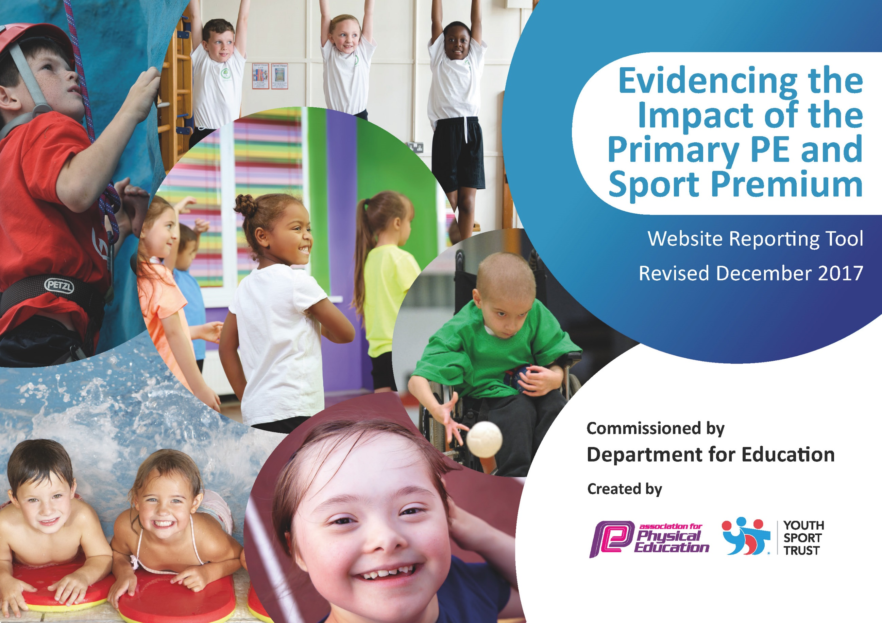

Schools must use the funding to make **additional and sustainable** improvements to the quality of PE and sport they offer. This means that you should use the Primary PE and Sport Premium to:

* develop or add to the PE and sport activities that your school already offers
* 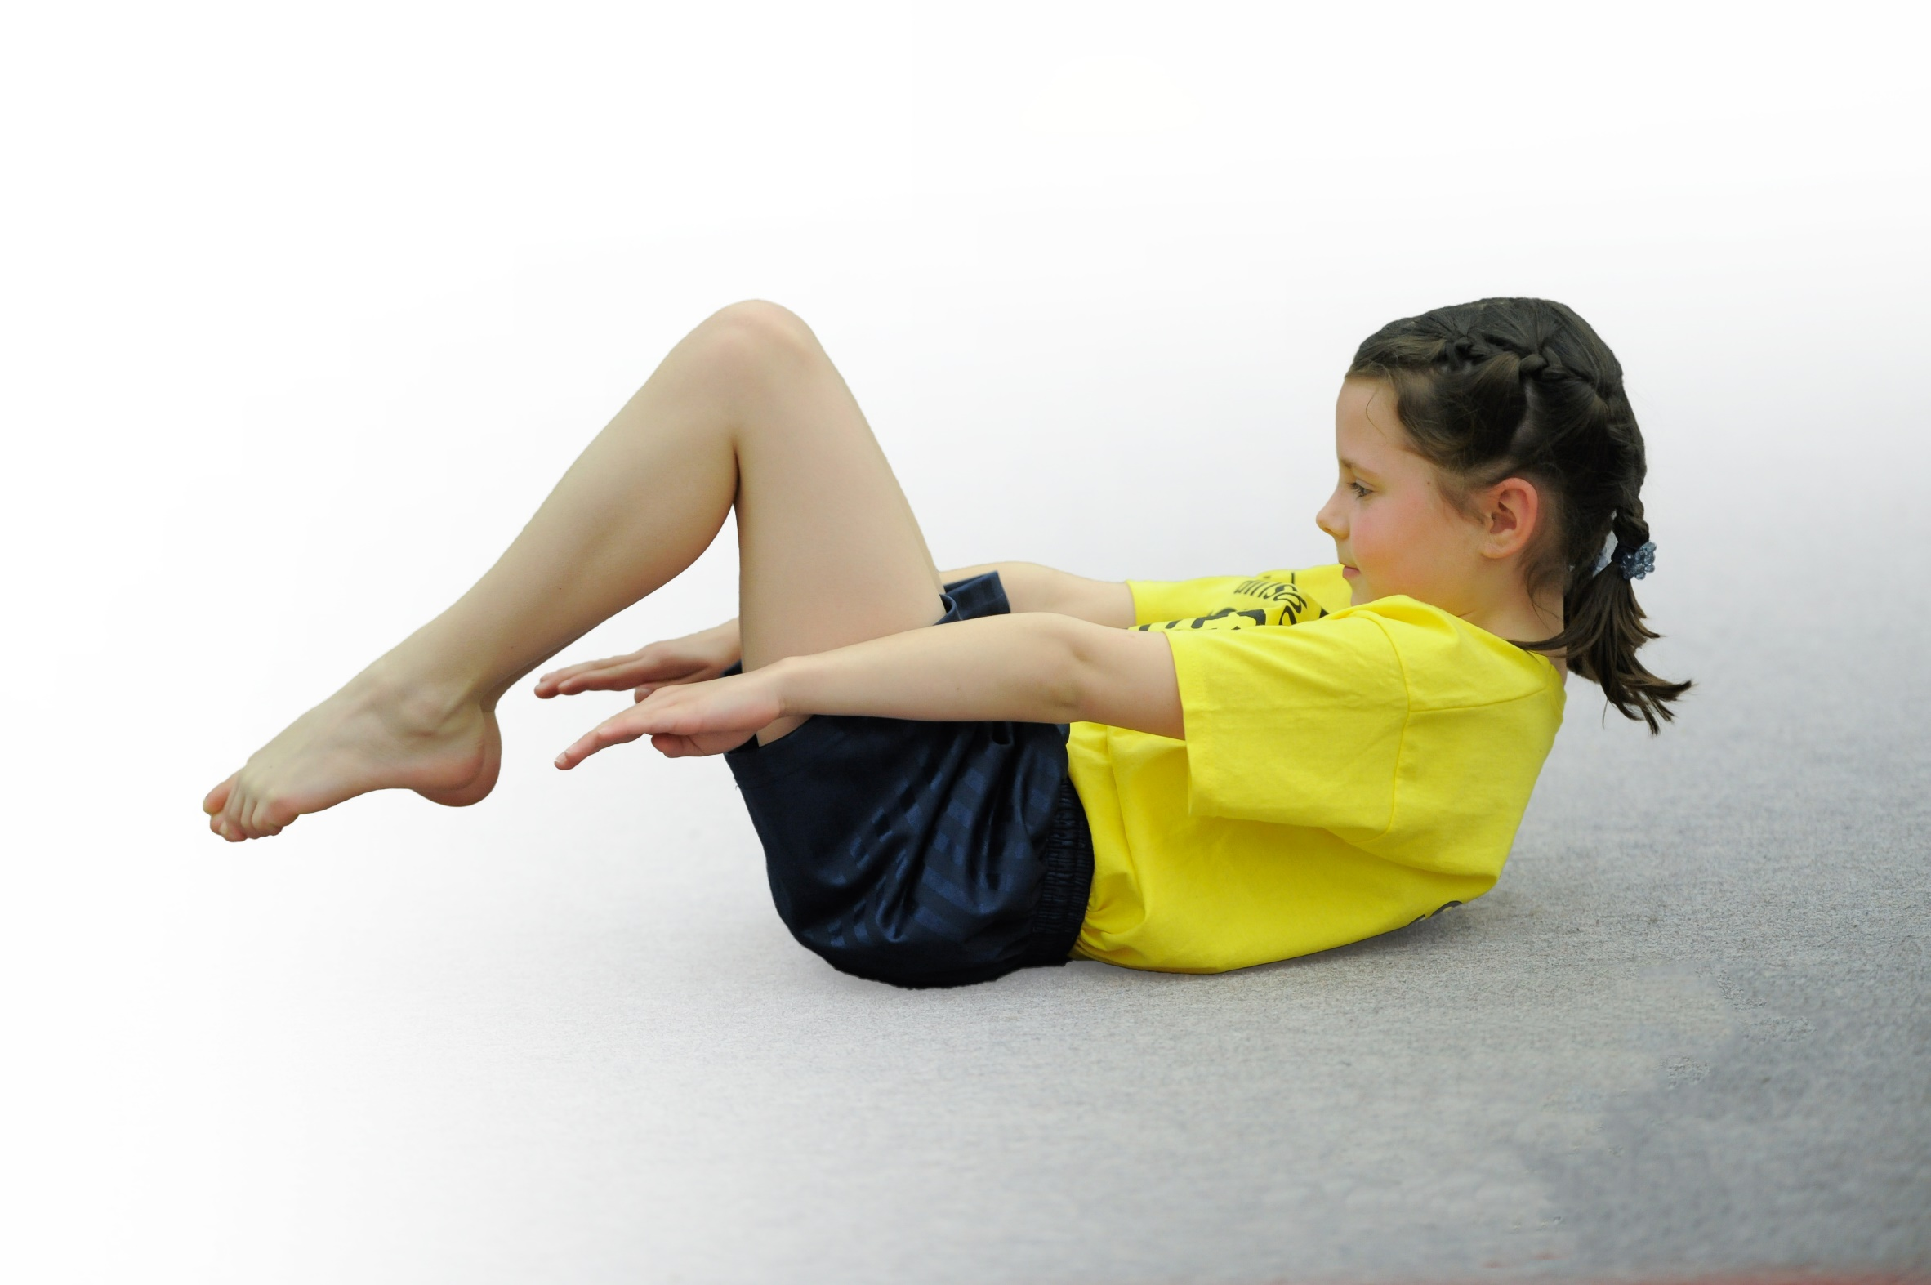build capacity and capability within the school to ensure that improvements made now will benefit pupils joining the school in future years

Please visit [gov.uk](https://www.gov.uk/guidance/pe-and-sport-premium-for-primary-schools) for the revised DfE guidance including the 5 key indicators across which schools should demonstrate an improvement. This document will help you to review your provision and to report your spend. DfE encourages schools to use this template as an effective way of meeting the reporting requirements of the Primary PE and Sport Premium.

We recommend you start by reflecting on the impact of current provision and reviewing the previous spend.

Under the [Ofsted Schools Inspection Framework](https://www.gov.uk/government/publications/school-inspection-handbook-from-september-2015), inspectors will assess how effectively leaders use

the Primary PE and Sport Premium and measure its impact on outcomes for pupils, and how effectively [governors](https://www.gov.uk/government/publications/governance-handbook) hold them to account

for this.

Schools are required to [publish details](https://www.gov.uk/guidance/what-maintained-schools-must-publish-online#pe-and-sport-premium-for-primary-schools) of how they spend this funding as well as on the impact it has on pupils’ PE

and sport participation and attainment.

We recommend regularly updating the table and

publishing it on your website as evidence

of your ongoing review into how you are using the money

to secure maximum, sustainable impact. To see an example of how to complete the table please click [HERE](http://www.afpe.org.uk/physical-education/wp-content/uploads/Template-Exemplification.pdf).

Support for review and reflection - considering the 5 key indicators from DfE, what development needs are a priority for your setting and your students now and why? Use the space below to reflect on previous spend, identify current need and priorities for the future.

**Impact self-evaluation for 2020 to 2021**

|  |  |
| --- | --- |
| Key achievements to date: | Areas for further improvement and baseline evidence of need: |

|  |  |
| --- | --- |
| We have been successful in using the sports premium to support the well-being of our children. This has been through the payment of our 1 day a week onsite art therapist. This is providing support for children that are struggling post lockdown.    We have been members of the sports partnership | To ensure that our swimming provision meets NC expectations.  To support the CPD of our inexperienced teachers  Where possible, during the academic year, the PECo will develop the teacher’s subject knowledge.  To audit value for money for our sports subscriptions. |

|  |  |
| --- | --- |
| Meeting national curriculum requirements for swimming and water safety | Please complete all of the below*: |
| What percentage of your current Year 6 cohort swim competently, confidently and proficiently over a distance of at least 25 metres? | Not able to complete due to lockdown. To be reviewed in the summer. |
| What percentage of your current Year 6 cohort use a range of strokes effectively [for example, front crawl, backstroke and breaststroke]? | Not able to complete due to lockdown. To be reviewed in the summer. |
| What percentage of your current Year 6 cohort perform safe self-rescue in different water-based situations? | Not able to complete due to lockdown. To be reviewed in the summer. |
| Schools can choose to use the Primary PE and Sport Premium to provide additional provision for swimming but this must be for activity **over and above** the national curriculum requirements. Have you used it in this way? | Not able to complete due to lockdown. To be reviewed in the summer. |
|  | |

*Schools may wish to provide this information in April, just before the publication deadline.

**Action Plan and Budget Tracking**

Capture your intended annual spend against the 5 key indicators. Clarify the success criteria and evidence of impact that you intend to measure to evaluate for students today and for the future.

|  |  |  |  |  |
| --- | --- | --- | --- | --- |
| **Academic Year:** 2020/2021 | **Total fund allocated:** £2100 | **Date Updated: January 2021** | |  |
| **Key indicator 1:** The engagement of all pupils in regular physical activity – Chief Medical Officer guidelines recommend that primary school children undertake at least 30 minutes of physical activity a day in school | | | |  |
|  |
| School focus with clarity on intended **impact on pupils**: | Actions to achieve: | Funding allocated: | Evidence and impact: | Sustainability and suggested next steps: |
| Members of the sports partnership:   * Partaking in competitive league games * Competitive football * Competitive netball * Cross country | Attend termly clusters  organize additional inter house competitions to support external competitive games | £2100 |  |  |
| **Key indicator 2:** The profile of PE and sport being raised across the school as a tool for whole school improvement | | | |  |
|  |
| School focus with clarity on intended **impact on pupils**: | Actions to achieve: | Funding allocated: | Evidence and impact: | Sustainability and suggested next steps: |
| To review our intent behind PE. This will include subject leadership training | That the subject leadership of PE is in-line with the St. Peter’s school vision. | £2,000 |  |  |

|  |  |  |  |  |
| --- | --- | --- | --- | --- |
| **Key indicator 3:** Increased confidence, knowledge and skills of all staff in teaching PE and sport | | | |  |
|  |
| School focus with clarity on intended  **impact on pupils**: | Actions to achieve: | Funding  allocated: | Evidence and impact: | Sustainability and suggested  next steps: |
| through the leadership of PE, our subject leader will provide coaching sessions | to provide support to develop pedagogy and teaching of PE | hours for overtime if needed. |  |  |
| **Key indicator 4:** Broader experience of a range of sports and activities offered to all pupils | | | |  |
|  |
| School focus with clarity on intended  **impact on pupils:** | Actions to achieve: | Funding  allocated: | Evidence and impact: | Sustainability and suggested  next steps: |
| To continue to develop our mental health offer.  Employ a mental health therapist for art or counseling. | to renew contract and audit provision when appropriate. | £12,000 |  |  |
| **Key indicator 5:** Increased participation in competitive sport | | | |  |
|  |
| School focus with clarity on intended  **impact on pupils**: | Actions to achieve: | Funding  allocated: | Evidence and impact: | Sustainability and suggested  next steps: |
| Members of the sports partnership:   * Partaking in competitive league games * Competitive football * Competitive netball * Cross country * CPD and clusters for teachers and PE co | Attend termly clusters  organize additional inter house competitions to support external competitive games | £2100  to be reviewed. |  |  |