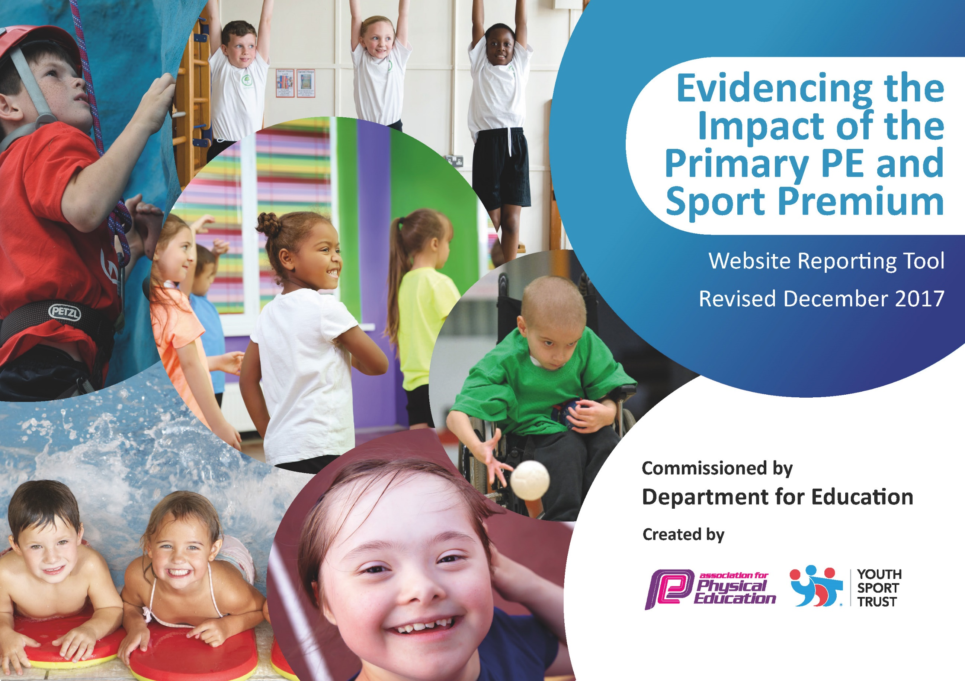

Schools must use the funding to make **additional and sustainable** improvements to the quality of PE and sport they offer. This means that you should use the Primary PE and Sport Premium to:

* develop or add to the PE and sport activities that your school already offers
* 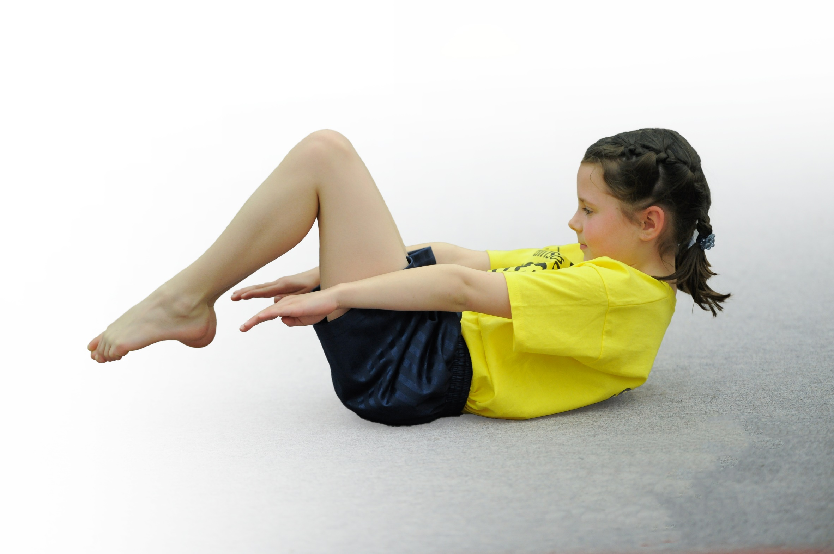build capacity and capability within the school to ensure that improvements made now will benefit pupils joining the school in future years

Please visit [gov.uk](https://www.gov.uk/guidance/pe-and-sport-premium-for-primary-schools) for the revised DfE guidance including the 5 key indicators across which schools should demonstrate an improvement. This document will help you to review your provision and to report your spend. DfE encourages schools to use this template as an effective way of meeting the reporting requirements of the Primary PE and Sport Premium.

We recommend you start by reflecting on the impact of current provision and reviewing the previous spend.

Under the [Ofsted Schools Inspection Framework](https://www.gov.uk/government/publications/school-inspection-handbook-from-september-2015), inspectors will assess how effectively leaders use

the Primary PE and Sport Premium and measure its impact on outcomes for pupils, and how effectively [governors](https://www.gov.uk/government/publications/governance-handbook) hold them to account

for this.

Schools are required to [publish details](https://www.gov.uk/guidance/what-maintained-schools-must-publish-online#pe-and-sport-premium-for-primary-schools) of how they spend this funding as well as on the impact it has on pupils’ PE

and sport participation and attainment.

We recommend regularly updating the table and

publishing it on your website as evidence

of your ongoing review into how you are using the money

to secure maximum, sustainable impact. To see an example of how to complete the table please click [HERE](http://www.afpe.org.uk/physical-education/wp-content/uploads/Template-Exemplification.pdf).

Support for review and reflection - considering the 5 key indicators from DfE, what development needs are a priority for your setting and your students now and why? Use the space below to reflect on previous spend, identify current need and priorities for the future.

**Impact self-evaluation for 2021 to 2022**

|  |  |
| --- | --- |
| Key achievements to date: | Areas for further improvement and baseline evidence of need: |

|  |  |
| --- | --- |
| We have been successful in using the sports premium to support the well-being of our children. This has been through the payment of our 1 day a week onsite art therapist. This is providing support for children that are struggling post lockdown.    We have been members of the sports partnership for many years and we have now been drawing on this further.  We have been awarded our bronze award.  We have purchased our new Complete PE scheme of work ready for September 22. | * Develop ECT skills of teaching PE * Model sessions with ECTS * Ensure that swimming provision is of high quality. |

|  |  |
| --- | --- |
| Meeting national curriculum requirements for swimming and water safety | Please complete all of the below*: |
| What percentage of your current Year 6 cohort swim competently, confidently and proficiently over a distance of at least 25 metres? | 80% |
| What percentage of your current Year 6 cohort use a range of strokes effectively [for example, front crawl, backstroke and breaststroke]? | 80%. |
| What percentage of your current Year 6 cohort perform safe self-rescue in different water-based situations? | 80% |
| Schools can choose to use the Primary PE and Sport Premium to provide additional provision for swimming but this must be for activity **over and above** the national curriculum requirements. Have you used it in this way? | Some additional lessons used. |
|  | |

*Schools may wish to provide this information in April, just before the publication deadline.

**Action Plan and Budget Tracking**

Capture your intended annual spend against the 5 key indicators. Clarify the success criteria and evidence of impact that you intend to measure to evaluate for students today and for the future.

|  |  |  |  |  |
| --- | --- | --- | --- | --- |
| **Academic Year:** 2021/2022 | **Total fund allocated:** £2100 | **Date Updated: September 2022** | |  |
| **Key indicator 1:** The engagement of all pupils in regular physical activity – Chief Medical Officer guidelines recommend that primary school children undertake at least 30 minutes of physical activity a day in school | | | |  |
|  |
| School focus with clarity on intended **impact on pupils**: | Actions to achieve: | Funding allocated: | Evidence and impact: | Sustainability and suggested next steps: |
| Members of the sports partnership:   * Partaking in competitive league games * Competitive football * Competitive netball * Cross country | Attend termly clusters  organize additional inter house competitions to support external competitive games | £2100 | We continue to take advantage of the sports partnership. We have attended some CPD sessions for staff, attended many events and have been awarded our bronze PE award. | To maintain and keep on going. |
| **Key indicator 2:** The profile of PE and sport being raised across the school as a tool for whole school improvement | | | |  |
|  |
| School focus with clarity on intended **impact on pupils**: | Actions to achieve: | Funding allocated: | Evidence and impact: | Sustainability and suggested next steps: |
| To review our intent behind PE. This will include subject leadership training and the trialing of a new scheme of work- Complete PE | That the subject leadership of PE is in-line with the St. Peter’s school vision.  To explore the use of Complete PE and then roll out across the school | £2,000  £1,500 | This was undertaken and the PE subject lead benefited from the courses. They attended ‘Outstanding’ practice courses, managing your subject and monitoring your subject.  We have trialed the Complete PE package in YN and this has been proven to be of high quality. We shall be rolling this out across the school.  We have increased our sports clubs to increase the profile and positives of PE. We have woven in a high quality well being and mental health time as well. | The PE subject lead left so we will need to update our new lead.  Focus on the September 2022 inset day. |

|  |  |  |  |  |
| --- | --- | --- | --- | --- |
| **Key indicator 3:** Increased confidence, knowledge and skills of all staff in teaching PE and sport | | | |  |
|  |
| School focus with clarity on intended  **impact on pupils**: | Actions to achieve: | Funding  allocated: | Evidence and impact: | Sustainability and suggested  next steps: |
| The following of Complete PE across the school | To implement in 2022 to 2023. | £1,500 | We have began the process of implementing this across the school and this is going to be evaluated. |  |
| **Key indicator 4:** Broader experience of a range of sports and activities offered to all pupils | | | |  |
|  |
| School focus with clarity on intended  **impact on pupils:** | Actions to achieve: | Funding  allocated: | Evidence and impact: | Sustainability and suggested  next steps: |
| To continue to develop our mental health offer.  We have increased, significantly, our club offer with sports. This is to increase the competitive element of school | to renew contract and audit provision when appropriate.  To deploy funding for clubs and to explore a range of clubs | £12,000  Up to £50 an hour | This was spent and used to improve our mental health. Some mental health CPD was used and this proved successful. For the children that accessed the service, they have been reintegrated into school life.  We have managed to identify boxing and we will be looking for more sporting clubs. | We will be using our own in house mental health support. We will be sending a member of staff on senior mental health training. We will be offering mental health and wellbeing days termly. |
| **Key indicator 5:** Increased participation in competitive sport | | | |  |
|  |
| School focus with clarity on intended  **impact on pupils**: | Actions to achieve: | Funding  allocated: | Evidence and impact: | Sustainability and suggested  next steps: |
| Members of the sports partnership:   * Partaking in competitive league games * Competitive football * Competitive netball * Cross country * CPD and clusters for teachers and PE co | Attend termly clusters  organize additional inter house competitions to support external competitive games | £2100  to be reviewed. | See above. |  |