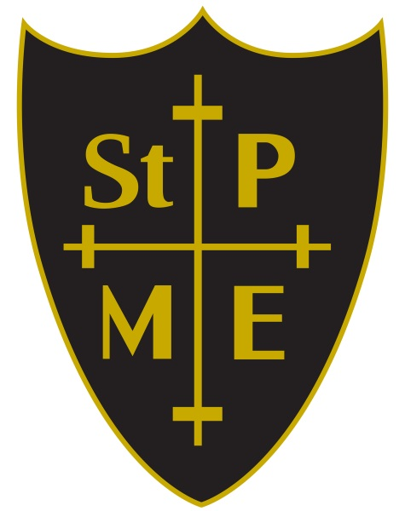

St. Peter’s

Church of England (VA)

Primary school



Physical Education Long Term Plan

Physical Education Long Term Plan

|  |  |  |  |  |  |  |  |
| --- | --- | --- | --- | --- | --- | --- | --- |
| Term | Foundation Stage | Year 1 | Year 2 | Year 3 | Year 4 | Year 5 | Year 6 |
| Autumn 1 | Hands 1  Ourselves  Jumping 1  Nursery and Rhymes | Running 1  Health and Wellbeing | Dodging 1  Explorers | Game Sense Invasion  Boccia | Game Sense Invasion  Boccia | Game Sense Invasion  Health Related Exercise | Game Sense Invasion  Health Related Exercise |
| Autumn 2 | Hands 1  Jumping 1  Moving  Dinosaurs | Hands  Heroes | Hands 1  Linking | Communication and tactics  Wild Animals | Problem Solving  Space | Tag Rugby  Counter Balance and Counter Tension | Hockey  Carnival |
| Spring 1 | Nursery rhymes  Moving  Hands 1  High, low, over and under | Feet 1  Wide, narrowed, curled | Feet 1  Mr Candy Man’s Sweet Shop | Basketball  Symmetry and asymmetry | Handball  Bridges | Football  Greeks | Tag Rugby  Matching and Mirroring |
| Spring 2 | Ourselves  Feet 1  Games for understanding  Feet 1 | Hands 2  The Zoo | Pathways  Games for Understanding | Handball  Witches and Wizards | Hockey  Cats | Orienteering  Street Art | Swimming  Prejudice and Discrimination |
| Summer 1 | Walking  Dinosaurs  Ourselves  Feet 1 | Jumping 1 Rackets, balls and bats | Jumping 1  Rackets, balls and bats | Rounders  Tennis | Tennis  Basketball | Badminton  Dodgeball | badminton    Leadership |
| Summer 2 | High, low, over and under  Sports day  Walking 2 | Games for understanding  Sports Day | Team Building  Sports Day | Athletics  Sports Day | Cricket  Athletics | Rounders  Athletics | Cricket  Athletics |

|  |  |
| --- | --- |
| Design and Technology National Curriculum Objectives: | |
| Purpose | A high-quality physical education curriculum inspires all pupils to succeed and excel in competitive sport and other physically-demanding activities. It should provide opportunities for pupils to become physically confident in a way which supports their health and fitness. Opportunities to compete in sport and other activities build character and help to embed values such as fairness and respect |
| Aims | The national curriculum for physical education aims to ensure that all pupils:  ♣ develop competence to excel in a broad range of physical activities  ♣ are physically active for sustained periods of time  ♣ engage in competitive sports and activities  ♣ lead healthy, active lives. |

|  |  |
| --- | --- |
|  | Subject Content: |
| KS1 | Pupils should develop fundamental movement skills, become increasingly competent and confident and access a broad range of opportunities to extend their agility, balance and coordination, individually and with others. They should be able to engage in competitive (both against self and against others) and co-operative physical activities, in a range of increasingly challenging situations.  Pupils should be taught to:  ♣ master basic movements including running, jumping, throwing and catching, as well as developing balance, agility and co-ordination, and begin to apply these in a range of activities  ♣ participate in team games, developing simple tactics for attacking and defending  ♣ perform dances using simple movement patterns. |

|  |  |
| --- | --- |
| KS2 | Pupils should continue to apply and develop a broader range of skills, learning how to use them in different ways and to link them to make actions and sequences of movement. They should enjoy communicating, collaborating and competing with each other. They should develop an understanding of how to improve in different physical activities and sports and learn how to evaluate and recognise their own success.  Pupils should be taught to:  ♣ use running, jumping, throwing and catching in isolation and in combination  ♣ play competitive games, modified where appropriate [for example, badminton, basketball, cricket, football, hockey, netball, rounders and tennis], and apply basic principles suitable for attacking and defending  ♣ develop flexibility, strength, technique, control and balance [for example, through athletics and gymnastics]  ♣ perform dances using a range of movement patterns  ♣ take part in outdoor and adventurous activity challenges both individually and within a team  ♣ compare their performances with previous ones and demonstrate improvement to achieve their personal best. |
| Swimming | All schools must provide swimming instruction either in key stage 1 or key stage 2.  In particular, pupils should be taught to:  ♣ swim competently, confidently and proficiently over a distance of at least 25 metres  ♣ use a range of strokes effectively [for example, front crawl, backstroke and breaststroke]  ♣ perform safe self-rescue in different water-based situations. |