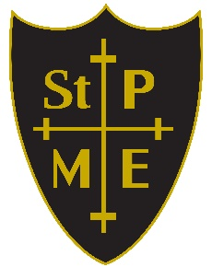

St Peter’s VA Church of England School
One family, aiming high, together with God

Collective Worship Policy

September 2025 to September 2028

At St. Peter’s, we have the vision of working with our community and all within our school. We are dedicated to ensuring that our children flourish through our shared vision and parable of The Lost Sheep. Below is our collective worship policy that details how we worship through the week. Our children are taught about different faiths so that they can embrace all in their spiritual journey. This links with our school vision by ensuring that children are armed with the skills and knowledge to love all. This will remove stigma and discrimination from our lives and support our children to live a loving life like Jesus.

Collective Worship at St. Peter’s

‘Collective Worship’ is a time when the whole school or groups within the school meet together to engage in relevant, meaningful experiences, providing opportunities for the pupils’ spiritual, moral, social and cultural development. Our collective worship is linked to our school vision of, One Family, Aiming High, Learning Together with God,’ and our school parable of ‘The Lost Sheep’.

At St. Peter’s, collective worship is set within the context of ‘Assemblies’ – which may include other features besides those required of collective worship.

Aims and Purpose
During collective worship we aim to:

- Fulfil statutory requirements of a daily act of collective worship for all pupils.
- To develop the children’s skills in managing their own internal, spiritual journey
- Widen the children’s knowledge and understanding of the teaching of Jesus and the bible
- Reflect on values that Christian character have on our own beliefs.
- Allow a pause for reflection and stillness in the midst of the pressure of the school day.
- Develop a community spirit, a common ethos and shared values.
- Provide a variety of opportunities for spiritual, moral, social and cultural development.
- Provide opportunities for expressing shared experiences and interests and for celebrating special occasions together.
- Provide opportunities in which pupils interact with other year groups, staff and on occasions the wider community, as well as offering opportunities to perform and respond to a presentation of readings, music, dance, drama or prayer.

The School Community
Assemblies and conducted in a manner which is sensitive to the faiths and beliefs of all members of the school community. Assemblies are regarded as a special time in the day, provide periods of calm reflection and are conducted accordingly. Children are expected to behave respectfully and thoughtfully and are asked to come in and leave assemblies in a quiet manner. Our whole school assemblies are interwoven to the worship for the week.

Organisation of Collective Worship
Collective worship involves members of the school coming together and participating in an assembly each day. An assembly may involve all of the pupils in the school, separate key stage or class assemblies. The time of the assembly may vary.

During the whole school assembly staff are encouraged to stay with the children in order to promote a sense of community. In each assembly there will be a short time given to reflect on the stimulus. To focus attention a candle might be lit, a picture or image displayed, a poem read, songs sang etc.

Prayer
Reading a prayer can be appropriate as long as the integrity of all those present is respected.
Prayer may be part of the period of reflection and stillness with children invited to participate in prayer if they wish.
Every effort is made to show sensitivity towards personal faiths and to include all pupils and staff in collective worship. For example when using a prayer from a particular faith, this will be introduced with sensitivity and pupils will not be required to say or affirm prayers which they do not believe.

A prayer may be introduced like this: I am going to read a Christian (Hindu, Buddhist........) prayer. I would like you to think carefully about the words. Some of you might wish to make the words your own (Christians might do this by saying ‘Amen’).

Singing
The act of singing can be a very positive opportunity for celebration or reflection. The selection of songs will respect the integrity of those present.

In order to comply with the law, Singing assemblies will include an opportunity for pupils to reflect on some of the words they are singing and to respond through a moment of quietness or prayer in an atmosphere that is one of reverence.

The songs sang are of Christian faith for the most part however, on occasions, other songs will be listened to and linked with our worship for the week.

Collective Worship Weekly Timetable
Assemblies are normally conducted by the Headteacher, Fr Mark, Assistant Head or other members of Staff, but are sometimes led by visitors to the school e.g. education guest

Monday | Fr Simon’s assembly to start our worship for the week
Tuesday | Tuesday - class assembly using the same Bible story using a lectio divina technique
Wednesday | Wonder Wednesday - in class - using the output from Tuesday s assembly to then ask children to think of pictures or films or music that resonate with that theme.
Thursday | Key stage assembly - using the material generated over the week
Friday | End of the week – Reflection time
Friday | Celebration assembly linked with worship for the week

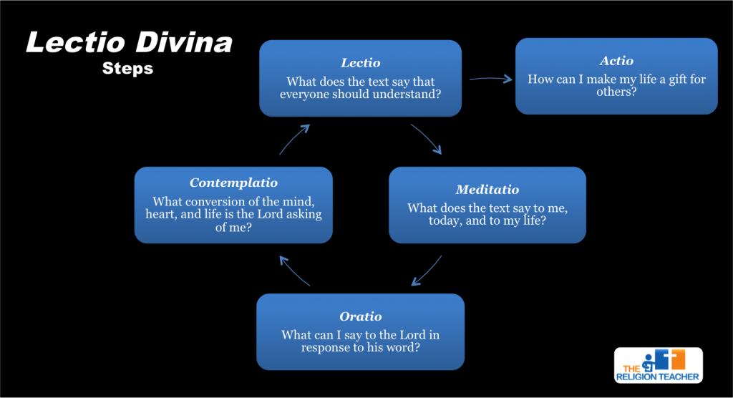

Content
The content of an assembly may reflect any of the following:
- marking the celebration of a broad range of religious and cultural festivals that reflect a diversity of faiths through our unique Christian ethos
- examples of lives of people of faith and other good human beings
- stories supporting themes from a range of sources and cultures
- response to key local, national and international events
- providing an opportunity to think about their own beliefs
- putting things into practice e.g. supporting charities
- providing a moment for silent reflection/prayer
- celebration of successes of members of the school community
- performances or presentations from members of the school community
- input from visiting speakers

Classroom Collective Worship
Classroom collective worship is valuable because:
- Children can be given greater opportunity to participate and respond.
- Children will be able to link the worship theme for the week with our school vision and values.
- Children are more likely to offer their deeper thoughts and feelings in a more intimate setting.
- Direct reference can be made to the children’s work in curriculum areas.
- Stimulus material can be closely matched to the children’s age and abilities

Celebrating Achievements
Assemblies may also reflect the achievements and learning of the children. We encourage children to participate by holding celebration assemblies and class assemblies, during which children may show their work and share successes with others, and can raise issues that they have discussed in their classes. These assemblies provide an opportunity to reward children for their achievements both in and out of school and celebrate them together. They also play an important part in promoting the ethos of the school - that all children and their achievements are valued.

Announcements
If announcements are to be given at the same time as an act of worship then they will be of a positive nature, which at times may enhance the act of worship itself. Announcements will be made at the end of the act of worship after a clearly defined break; a change of personnel, music, a moment of silence, the candle being distinguished etc.

Right of Withdrawal from Collective Worship
Parents retain the right to withdraw their children from parts or all acts of collective worship. Any pupil who is withdrawn from an act or acts of Collective Worship will be supervised during that time by a member of the school staff.

If you have any questions or concerns please contact the head through the school office.

